

**Introduction to Development and Operations**

**CSC4725**

**Cloud Fundamentals Lab 2**

**Group member 1**: Ahmed Ibrahim **Regno**: 2112300

**Group member 2**: Syed Haris Ahmed **Regno**: 2112333

**TASK1:**

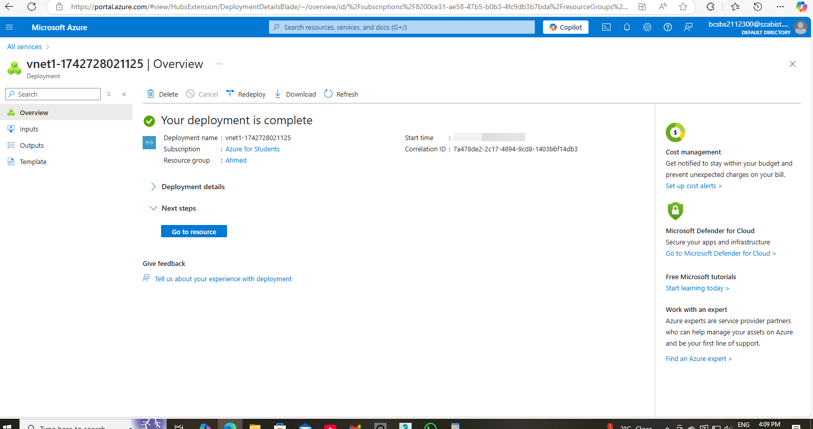

**TASK2:**

